 | 7.1.21 Editors - 3D View - Header - Curve - Edit mode - Curve menu
Table of content
Detailed Table of content 1
Edit Mode - Curve Menu 5
Transform 5
To Sphere 5
Shear 6
Bend 7
Push/Pull 7
Warp 8
Randomize Transform 8
Radius 9
Move Texture Space 10
Scale Texture Space 11
Set Dimensions 12
Mirror submenu 13
Interactive Mirror 13
X Global, Y Global etc. 13
Snap submenu 13
Snap 14
Operators 14
Duplicate 14
Split 15
Separate 15
Toggle Cyclic 15
Decimate Curve 15
Set Spline Type 16
Show / Hide 16
Delete Vertices 16
Delete Segment 16
Dissolve Vertices 17

Detailed Table of content

Detailed table of content
Detailed Table of content 1
Edit Mode - Curve Menu 5
Transform 5
To Sphere 5
Usage 5
Last Operator To Sphere 6
Factor 6
Mirror Editing 6
Proportional editing 6
Proportional Falloff 6
Proportional Size 6
Connected 6
Projected(2D) 6
Shear 6
Last Operator Shear 6
Offset 6
Axis 6
Axis Ortho 7
Orientation 7
Mirror Editing 7
Proportional editing 7
Proportional Falloff 7
Proportional Size 7
Connected 7
Projected(2D) 7
Bend 7
Push/Pull 7
Last Operator Push/Pull 7
Distance 7
Mirror Editing 7
Proportional editing 8
Proportional Falloff 8
Proportional Size 8
Connected 8
Projected(2D) 8
Warp 8
Last operator Warp 8
Warp Angle 8
Offset Angle 8
Min 8
Max 8
Randomize Transform 8
Last Operator Randomize Transform 8
Amount 8
Uniform 9
Normal 9
Random Seed 9
Radius 9
Last Operator Transform 9
Values 9
Axis 9
Orientation 9
Mirror Editing 9
Proportional editing 9
Proportional Falloff 10
Proportional Size 10
Connected 10
Projected(2D) 10
Move Texture Space 10
Last Operator Move 10
Move 10
Orientation 10
Mirror Editing 11
Proportional editing 11
Proportional Falloff 11
Proportional Size 11
Connected 11
Projected(2D) 11
Scale Texture Space 11
Last Operator Resize 12
Scale 12
Orientation 12
Mirror Editing 12
Proportional editing 12
Proportional Falloff 12
Proportional Size 12
Connected 12
Projected(2D) 12
Set Dimensions 12
Last Operator Set Dimensions 13
New Dimensions 13
Mirror submenu 13
Interactive Mirror 13
X Global, Y Global etc. 13
Last Operator Mirror 13
Orientation 13
Constraint Axis 13
Snap submenu 13
Snap 14
Last operator Snap Selection to Cursor 14
Offset 14
Rotation 14
Operators 14
Duplicate 14
Last Operator Duplicate 14
Move X , Y , Z 14
Orientation 14
Mirror Editing 14
Proportional editing 14
Proportional Falloff 14
Proportional Size 15
Connected 15
Projected(2D) 15
Split 15
Separate 15
Toggle Cyclic 15
Last Operator Toggle Cyclic 15
Direction 15
Decimate Curve 15
Last Operator Decimate Curve 15
Ratio 15
Set Spline Type 16
Last Operator Set Spline Type 16
Type 16
Handles 16
Show / Hide 16
Show Hidden 16
Hide Selected 16
Last Operator Hide Selected 16
Unselected 16
Hide Unselected 16
Delete Vertices 16
Delete Segment 16
Dissolve Vertices 17

Edit Mode - Curve Menu

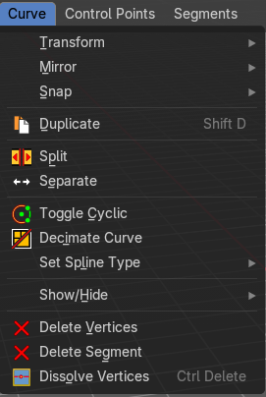
The curve menu just exists for curve objects.

Transform

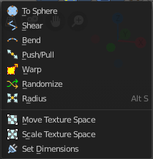

To Sphere
Shapes a selection of objects into the shape of a sphere. The calculation happens with the object origins.
In Object mode this tools requires to have more than one object selected.

Usage

Select the vertices, activate the tool, then drag the mouse in the 3D viewport. In the header you will read the current factor then. Which tells you how close you are towards the sphere shape.


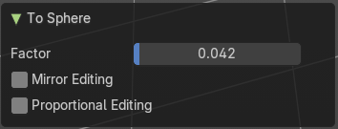
Last Operator To Sphere

Factor
The factor to transform the selection into a shape form.

Mirror Editing
Enable mirror editing.

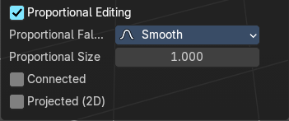
Proportional editing
Enables proportional editing. Activating proportional editing reveals further settings.

Proportional Falloff
Adjust the falloff methods.

Proportional Size
See and adjust the falloff radius.

Connected
The proportional falloff gets calculated for connected parts only.

Projected(2D)
The proportional falloff.

Shear
Shear shears the selection.
In Object mode this tools requires to have more than one object selected.
The shear tool works along a imaginary 2d plane. The shear axis controls if the items are sheared along the x or the y axes of this plane. This is the plane along which the transformation happens. You can shear along the x or the y axis of this plane.
To make things even more complicated, the orientation of this imaginary plane is defined by the Axis and Axis Ortho items below.

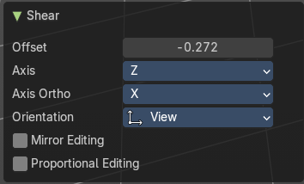
Last Operator Shear

Offset
Adjust an offset.

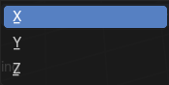
Axis
Defines one axis of the imaginary shear axis plane.

Axis Ortho
Defines the other axis of the imaginary shear axis plane.

Orientation
Choose the orientation for the shear action.

Mirror Editing
Enable mirror editing.

Proportional editing
Enables proportional editing. Activating proportional editing reveals further settings.

Proportional Falloff
Adjust the falloff methods.

Proportional Size
See and adjust the falloff radius.

Connected
The proportional falloff gets calculated for connected parts only.

Projected(2D)
The proportional falloff gets calculated in the screen space. Depth doesn't play a role. When it's in the radius, then it gets calculated.

Bend
Bends the selection.

Push/Pull
It pushes or pulls the object positions relative to the center of the selection.
In Object mode this tool requires to have more than one object selected.

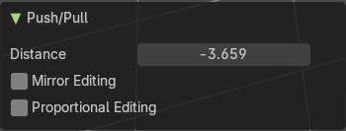
Last Operator Push/Pull

Distance
Adjust the distance of influence of the tool.

Mirror Editing
Enable mirror editing.

Proportional editing
Enables proportional editing. Activating proportional editing reveals further settings.

Proportional Falloff
Adjust the falloff methods.

Proportional Size
See and adjust the falloff radius.

Connected
The proportional falloff gets calculated for connected parts only.

Projected(2D)
The proportional falloff gets calculated in the screen space. Depth doesn't play a role. When it's in the radius, then it gets calculated.


Warp
Warps a mesh selection between two defined points. This also works with curves.

Last operator Warp

Warp Angle
The strength of the warp effect.

Offset Angle
An offset angle to bend side wards.


Min
The start point.

Max
The end point.

Randomize Transform
This tool allows randomizes the positions of the selected vertices.


Last Operator Randomize Transform

Amount
Adjust the amount.

Uniform
The uniform offset distance.

Normal
Align the offset direction to the normals.

Random Seed
The seed value for randomization.

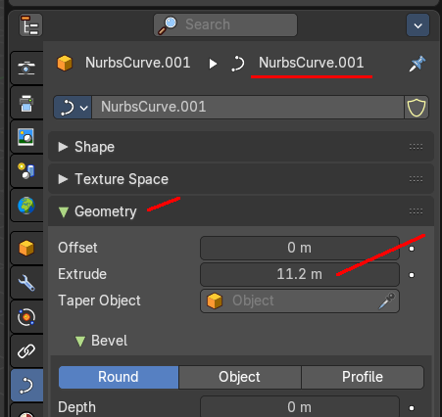
Radius
Scales the selected geometry of a curve along its normals. Transform orientation and Pivot point gets ignored.
A positive value pushes the vertices outwards. A negative value pushes the vertices inwards.
The curve needs to have geometry !

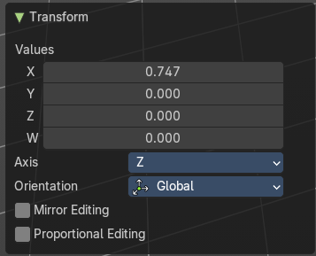
Last Operator Transform

Values
The transform values.

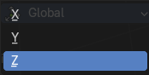
Axis
The transform axis.

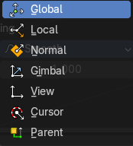
Orientation
Choose the orientation.

Mirror Editing
Enable Mirror Editing.

Proportional editing
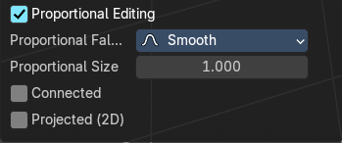
Enables proportional editing. Activating proportional editing reveals further settings.

Proportional Falloff
Adjust the falloff methods.

Proportional Size
See and adjust the falloff radius.

Connected
The proportional falloff gets calculated for connected parts only.

Projected(2D)
The proportional falloff gets calculated in the screen space. Depth doesn't play a role. When it's in the radius, then it gets calculated.


Move Texture Space
This tool relies at the move tool. With the difference that it moves the texture space instead of the object. It has also a very special use case, and just works with a material with a Texture Coordinate / Generated node. And requires to have the shading at Material or Rendered to see a result in the viewport.
In the viewport you will see the UV cage in black color. In the header you will see the values for the current position of the UV cage.
Note that once done and applied, there is no way to reset the UV cage back to zero. When you repeat the operation, then the values will start at 0 again. Even when the UV cage is already offset.


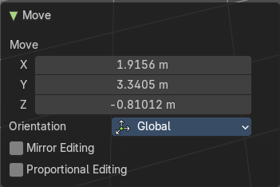
Last Operator Move

Move
Adjust in which directions you want to transform.

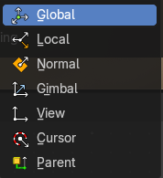
Orientation
Choose the orientation.

Mirror Editing
Enable mirror editing.

Proportional editing
Enables proportional editing. Activating proportional editing reveals further settings.

Proportional Falloff
Adjust the falloff methods.

Proportional Size
See and adjust the falloff radius.

Connected
The proportional falloff gets calculated for connected parts only.

Projected(2D)
The proportional falloff gets calculated in the screen space. Depth doesn't play a role. When it's in the radius, then it gets calculated.


Scale Texture Space
Scale Texture space is similar to the Move texture Space. With the only difference that it scales the UV space instead of moving it.
This tool relies at the scale tool. With the difference that it scales the texture space instead of the object. It has also a very special use case, and just works with a material with a Texture Coordinate / Generated node. And requires to have the shading at Material or Rendered to see a result in the viewport.
In the viewport you will see the UV cage in black color. In the header you will see the values for the current position of the UV cage.
Note that once done and applied, there is no way to reset the UV cage back to zero. When you repeat the operation, then the values will start at 0 again. Even when the UV cage is already offset.


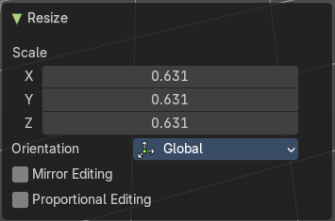
Last Operator Resize

Scale
Adjust in which directions you want to transform.

Orientation
Choose the orientation.

Mirror Editing
Enable mirror editing.

Proportional editing
Enables proportional editing. Activating proportional editing reveals further settings.

Proportional Falloff
Adjust the falloff methods.

Proportional Size
See and adjust the falloff radius.

Connected
The proportional falloff gets calculated for connected parts only.

Projected(2D)
The proportional falloff gets calculated in the screen space. Depth doesn't play a role. When it's in the radius, then it gets calculated.


Set Dimensions
Edit Mode Only!
Normally all scale operations in Bforartists are relative to the current selection and dimensions. And you always start with a relative value of 1.
Set dimensions allows to scale mesh selections in absolute world values. No matter how the initial values are. The new values gets set in the Last Operator.
Set dimensions is an add-on. You can turn it off in the add-ons section of the user preferences when you want.

Last Operator Set Dimensions


New Dimensions
When you activate the tool then you will see the world coordinates of the selection. Change the values to other world coordinates.

Mirror submenu

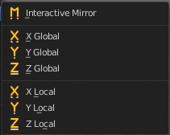
Mirror mirrors the selected geometry along the defined axis.

Interactive Mirror
Mirror by hotkeys. You activate the tool, type in x for x global for example, or x x for x local. And the selection gets mirrored

X Global, Y Global etc.
Mirrors the selection around the chosen axis.

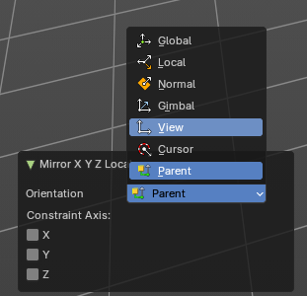
Last Operator Mirror
The Last Operator Mirror panel gives you tools to adjust the mirror action.


Orientation
Orientation is a drop-down box . Choose the type of orientation for the mirroring action.

Constraint Axis
Constraint Axis gives you again the possibility to define the mirror axis. You can choose more than one axis here.

Snap submenu


Snap
Choose several methods to snap one element to another. The menu items should be self explaining.

Last operator Snap Selection to Cursor
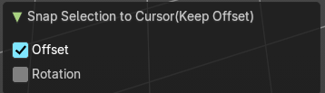
Some snap operations shows a last operation panel, some not.

Offset
If the selection should snap as a whole, or if each individual element of the selection should snap.

Rotation
If the selection should be rotated to match the cursor.

Operators

Duplicate
Duplicates the current selection. This can be a single control point or a whole curve.
The copy sticks to the mouse until you release it. A Right click while moving will reset the position of the duplicate. The duplicated part will be part of the same object.
When you drag the duplicate around you will see the position values in the header.

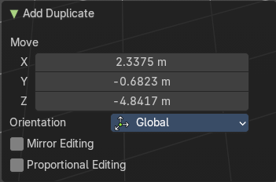
Last Operator Duplicate

Move X , Y , Z

Orientation
Choose the orientation.

Mirror Editing
Enable Mirror Editing.

Proportional editing
Enables proportional editing. Activating proportional editing reveals further settings.

Proportional Falloff
Adjust the falloff methods.

Proportional Size
See and adjust the falloff radius.

Connected
The proportional falloff gets calculated for connected parts only.

Projected(2D)
The proportional falloff gets calculated in the screen space. Depth doesn't play a role. When it's in the radius, then it gets calculated.

Split
Splits the curve at the selected control point(s). You need to select two control points to select the segment between it.

Separate
Separates the selected control points, and creates a new curve object out of it. You need to select two control points to select the segment between it.

Toggle Cyclic

Toggle Cyclic closes or opens the curve.

Last Operator Toggle Cyclic

Direction
Direction is a drop-down box . Choose the direction in which the curve gets closed.

Decimate Curve
Decimates the currently selected geometry. It starts with a Ratio of 1. Which means no decimation. The lower the ratio the more decimation you will get.

Last Operator Decimate Curve

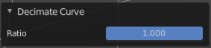
Ratio
Adjust the strength of decimation.

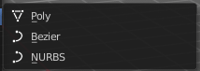
Set Spline Type
With set Spline Type you can set the type of the curve.
Poly is a straight line between the control points. Bezier has curve handlers. A nurbs curve has a control cage.




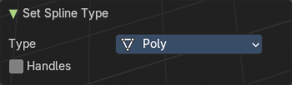
Last Operator Set Spline Type

Type
Type is a drop-down box . Choose the spline type

Handles
Use Handles when converting Bezier curves into polygons.


Show / Hide

Show Hidden
Makes all curve geometry in the scene visible again.

Hide Selected
Hides the selected curve geometry.

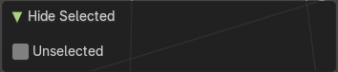
Last Operator Hide Selected

Unselected
Hides the not selected curve geometry.

Hide Unselected
Hides the not selected curve geometry. The selected geometry stays visible.

Delete Vertices
Dissolves the selected vertices. When removing vertices in between then the curve stays intact and connected.

Delete Segment
Removes the segment between the selected vertices.

Dissolve Vertices
Dissolves the selected vertices. When removing vertices in between then the curve stays intact and connected.

